Use Cases

UC Name | UC-26: Baggage Loading
Summary | Ground handling staff tracks, updates and manages baggage loading
Dependency | None
Actors | Primary: Ground Staff
Preconditions | - Plane is on ground  - Staff member is logged in
Description of the Main Sequence | - Step 1: Staff is logged in  - Step 2: Staff receives luggage from check-in and marks as loading  - Step 3: After luggage is moved with luggage car, staff members scan each tag as its being put on board to mark as loaded
Description of Alternate Sequence | - Luggage does not belong to flight→ System alerts staff to relocate luggage  - Luggage fails scan → System sends error report and asks for re-scan
Non-Functional Requirements | Errors handled quickly  Data updated in real time
Post-conditions | Luggage is successfully loaded into cargo and marked as such in system

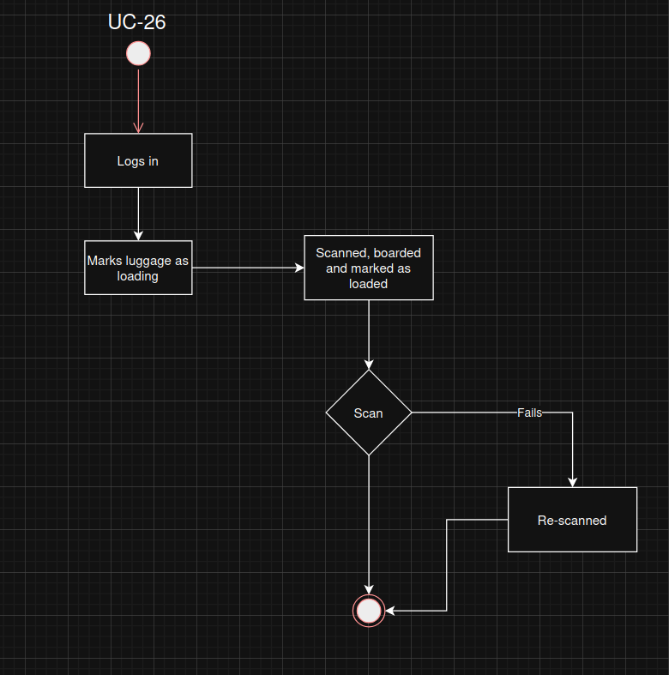

UC Name | UC-27: Final confirmation
Summary | Ground handling staff shall reconfirm that all processes have been fully completed to avoid
Dependency | UC-23, 24, 25, 26
Actors | Primary: Ground Staff
Preconditions | - Apron services, turnaround process and luggage handling has been completed  - Staff is logged in
Description of the Main Sequence | - Step 1: Staff re-confirms completion of turnaround process  - Step 2: Staff re-confirms completion of apron services  - Step 3: Staff re-confirms completion of luggage handling
Description of Alternate Sequence | - Failure to re-confirm marks plane as unfit for departure  - Issues found during re-confirmation are addressed
Non-Functional Requirements | Re-confirmation made easy to do to prevent avoidance
Post-conditions | Plane is fully cleared for departure
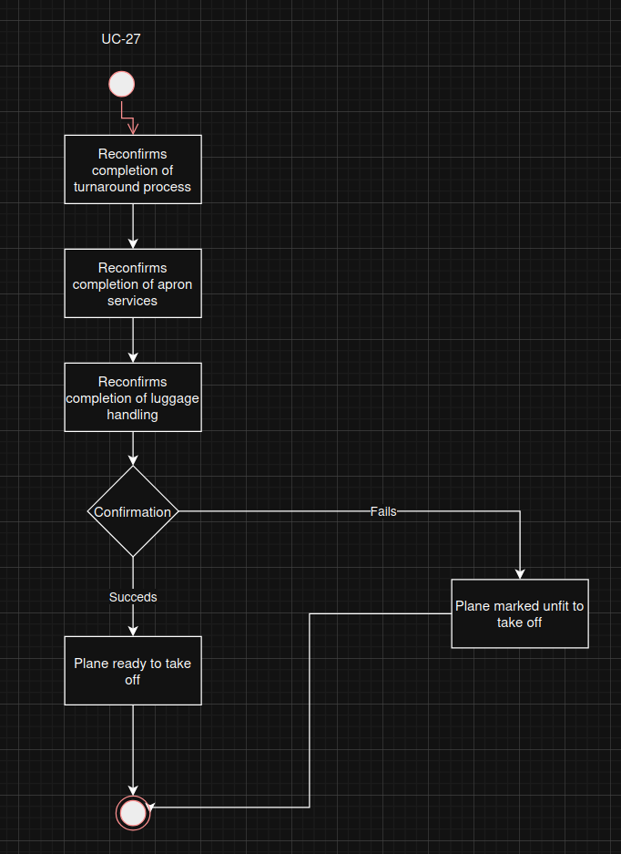

UC Name | UC-28: Passenger Check-in
Summary | Staff confirms check-in, identification and booking
Dependency | None
Actors | Primary: Airline staff
Preconditions | - Staff member is logged in
Description of the Main Sequence | - Step 1: Staff is logged in  - Step 2: Staff scans ticket  - Step 3: Staff scans id  - Step 4: System outputs if details match  - Step 5: System shows booking details.
Description of Alternate Sequence | - Failure of information matching
Non-Functional Requirements | Data updated in real time
Post-conditions | None

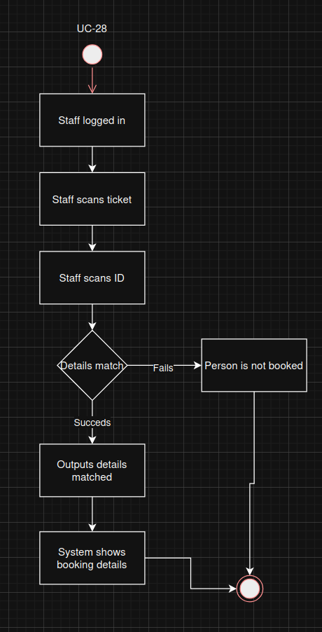

UC Name | UC-29: Boarding pass
Summary | Staff generates and issues boarding passes
Dependency | None
Actors | Primary: Airline staff
Preconditions | - Staff member is logged in  - Passenger is at check-in
Description of the Main Sequence | - Step 1: Staff receives id and booking information  - Step 2: Staff request printing of boarding pass  - Step 3: Staff hands pass to passenger
Description of Alternate Sequence
Non-Functional Requirements | Easy connectivity to pass printers
Post-conditions | None

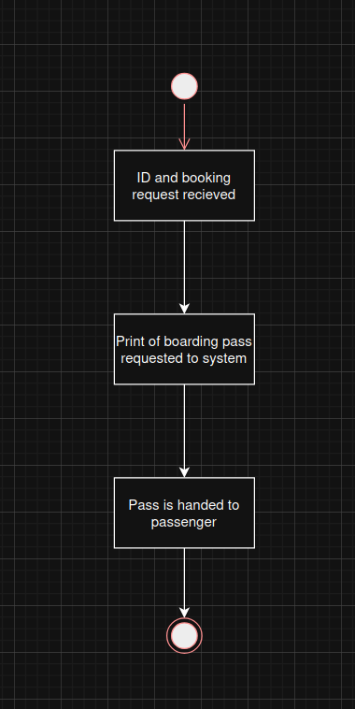

UC Name | UC-30: Seat handling
Summary | Airline staff shall assign, modify and reallocate seats for a flight
Dependency | None
Actors | Primary: Airline staff
Preconditions | - Staff logged in
Description of the Main Sequence | - Step 1: Staff sees request from passenger for seat relocation  - Step 2: Staff checks seat availability in system  - Staff accepts or denies relocation
Description of Alternate Sequence | - Staff receives last minute seat assignment, checks empty seats and assigns
Non-Functional Requirements | Intuitive gui
Post-conditions | None
